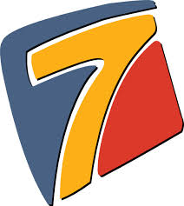
Sayings

The Apostle John tells us that he wrote his Gospel so that:

“You may believe that Jesus is the Christ, the Son of God,
and that believing you may have life in His name.” (20:31)

The whole Gospel is constructed around the number seven:
- Seven Miraculous Signs.
- Seven ‘I am’ Sayings
- and finally *Seven Words from the Cross.
This simple study focusses on the Seven Sayings of Jesus in John.
The phrase ‘I am’ - Eyw Eimi in the Greek was widely regarded at the time of Jesus as a name for God. It was the translation of Exodus 3:14 in the Greek Version of Old Testament. So for Jesus to use it of himself is to claim to be God! Even his opponents understood this - [John 8:48-59]
- I am the Bread of Life [John 6:25-59]
- I am the Light of the World. [John 8:12-30]
- I am the Gate for the Sheep. [John 10:1-10]
- I am the Good Shepherd. [John 10:11-19]
- I am the Resurrection and the Life. [John 11:17-44]
- I am the Way, the Truth and the Life. [John 14:1-14]
- I am the True Vine. [John 15:1-17]
Questions:
- What does this saying tell us about Jesus?
- What does it say to you?
- What are you going to do about it?
*Admittedly not all these are in John

